IT0049 WEB SYSTEM TECHNOLOGIES

Tasks for Today
Management System
CodeIgniter 4 implementation and submission documentation
Field | Details
Student | Angelo Kacey N. Pineda
Section | TW33
Assessment | Technical Summative Assessment 1
Repository | github.com/Angelowww11/TA1_CodeIgniter
Local environment | XAMPP MySQL and PHP 8.2

This document explains the completed application, database implementation, verification results, and the screenshots required for final submission.

PROJECT RESULT

Completed requirements
The application uses one shared MySQL data layer to produce four distinct pages. The home controller applies a date filter for the current day, while the complete task page retrieves every task in chronological order.
Route | Requirement | Implementation
/ | Today's tasks only | TaskModel where task_date equals the current date
/tasks | Complete task list | All task records ordered by task_date and id
/profile | One demo user | UserModel first record from users
/about | Developer page | Static view identifying the developer and MVC flow

Database result
- The tasks table contains 8 records spanning 4 distinct dates.
- Four records use the current date and appear on the Today dashboard.
- The users table contains exactly one demo record.
- The schema is supplied as both CodeIgniter migrations and database/tasks_today.sql.
- The seeder and SQL export calculate dates at execution or import time so the current-date filter remains demonstrable.

Code organization
Layer | Main files | Responsibility
Routes | app/Config/Routes.php | Maps the four URLs to controller methods
Controllers | Home, Tasks, Profile, Pages | Coordinates queries and view data
Models | TaskModel and UserModel | Represents the two MySQL tables
Views | pages, tasks, profile, partials | Renders escaped responsive HTML
Database | Migrations, seed, SQL export | Recreates the schema and sample records

LOCAL SETUP

Running the system with XAMPP
- Open XAMPP Control Panel and start Apache and MySQL.
- Open http://localhost/phpmyadmin and import database/tasks_today.sql.
- Confirm that the tasks_today database contains tasks and users.
- Copy env to .env if the local environment file does not already exist.
- Run C:\xampp\php\php.exe spark serve from the project directory.
- Open http://localhost:8080 and verify all four routes.

Alternative migration workflow
Instead of importing the SQL export, create an empty tasks_today database and run these commands from the project root:
C:\xampp\php\php.exe spark migrate
C:\xampp\php\php.exe spark db:seed TaskSystemSeeder

What to capture in XAMPP and phpMyAdmin
Screenshot | Required evidence
XAMPP services | Apache and MySQL show green Running indicators
Database structure | tasks_today selected with tasks and users visible
Tasks structure | id, title, status, task_date, and created_at fields
Tasks records | At least 8 rows across multiple dates, including today
Users record | Exactly 1 row for Angelo Kacey N. Pineda

Keep phpMyAdmin breadcrumbs, the selected database, and row-count indicators visible. Do not capture database passwords, the .env file, cookies, or private hosting credentials.

WEBSITE EVIDENCE 1

Today dashboard
The Welcome page shows only records whose task_date equals the current date. Its task summary is calculated from the same filtered result set.
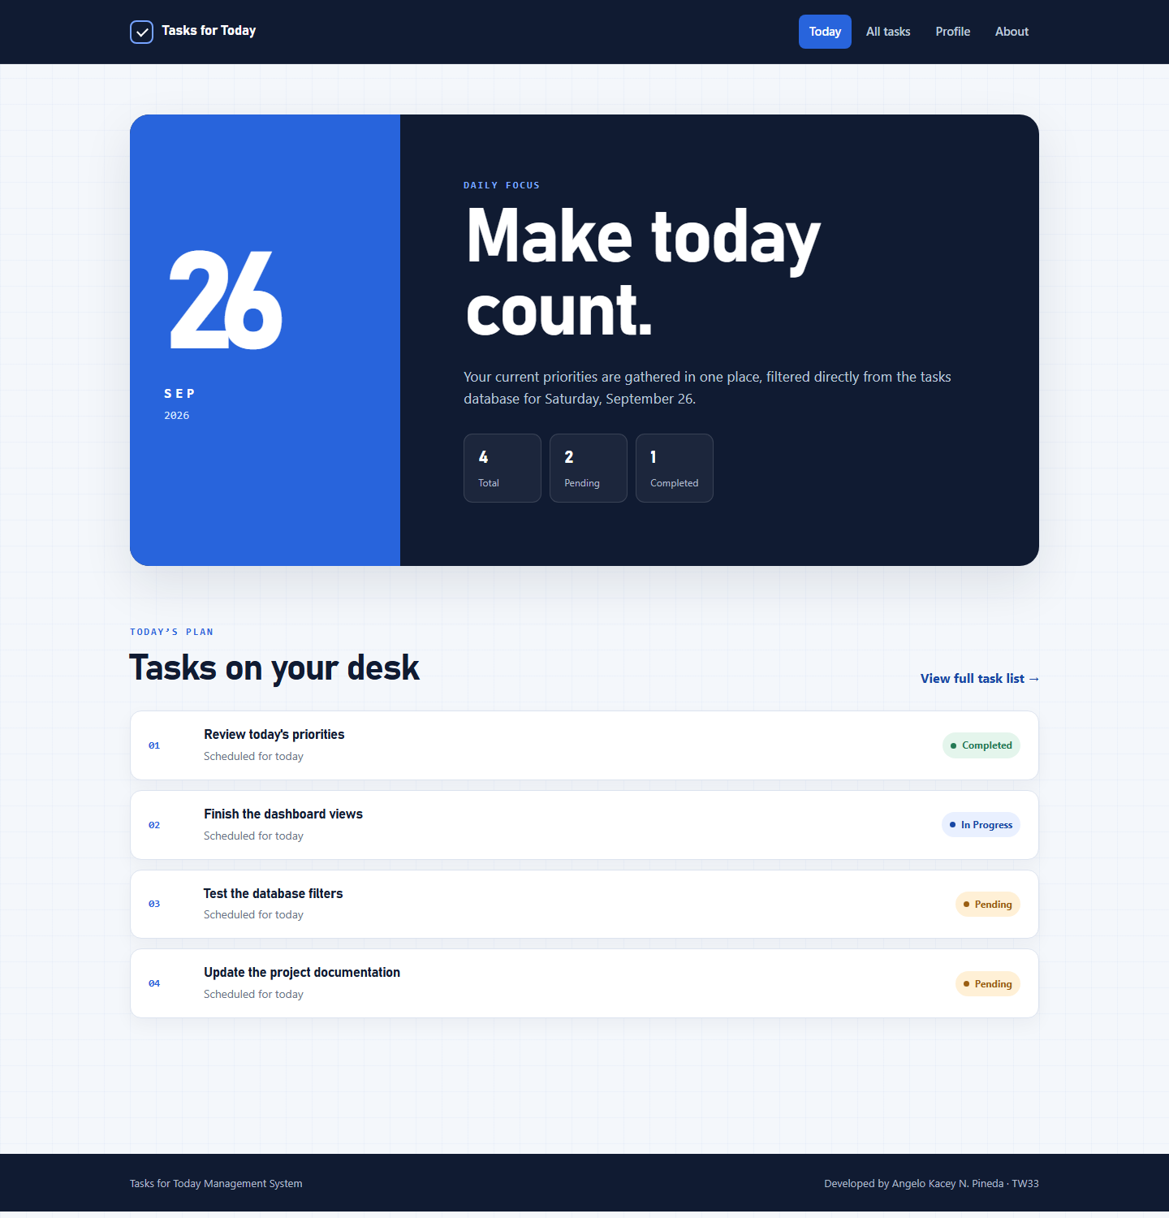
Figure 1. Today dashboard with four current-date tasks.

WEBSITE EVIDENCE 2

Complete task list
The complete listing is intentionally unfiltered and ordered first by task date, then by record ID.
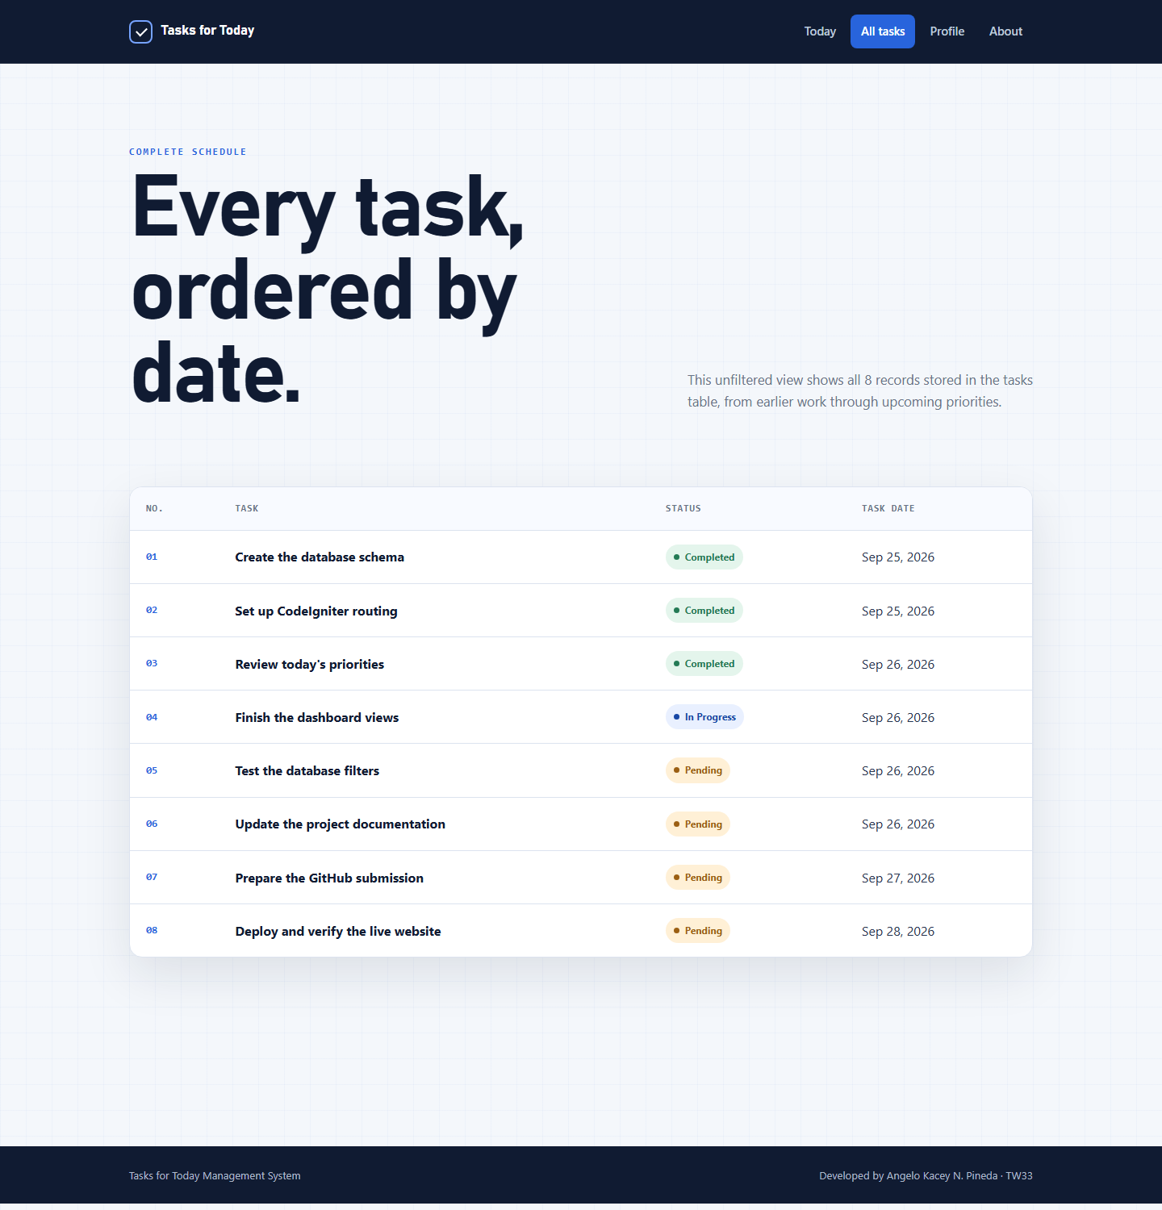
Figure 2. All eight task records ordered by date.

WEBSITE EVIDENCE 3

Demo user profile
The Profile page retrieves the single record from the users table through UserModel.
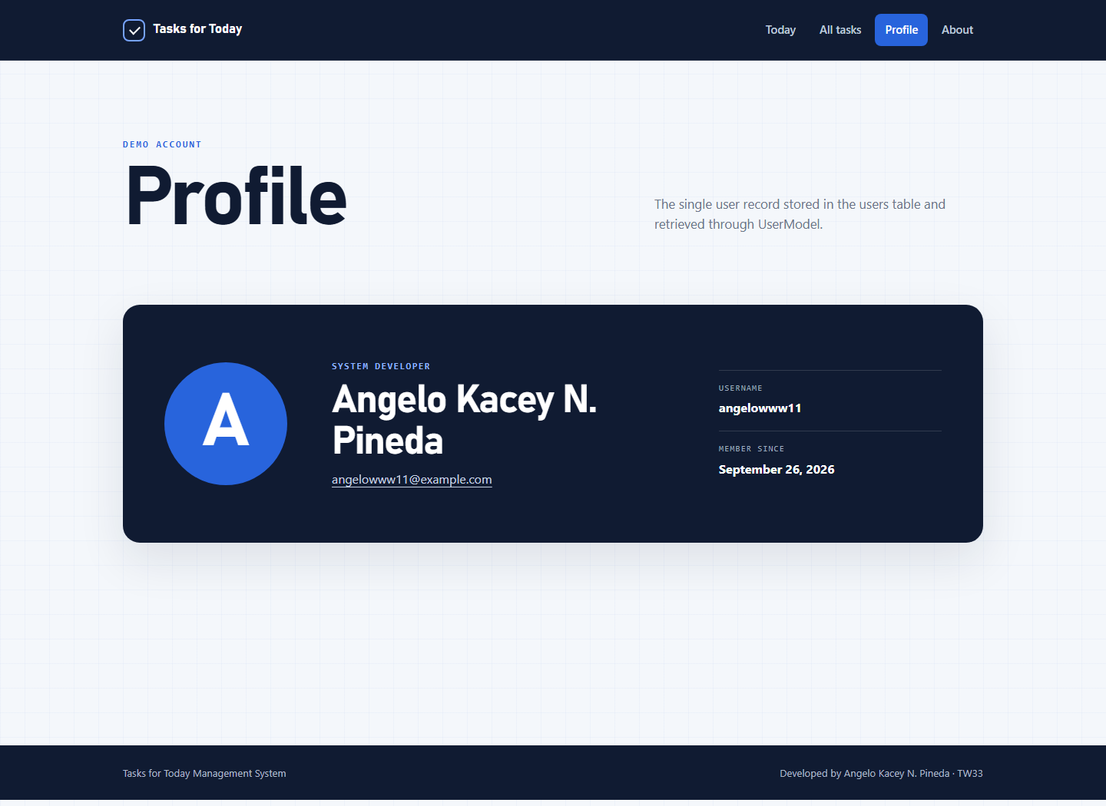
Figure 3. Profile page showing the single demo user.
- The page displays exactly one database record.
- The username, full name, email address, and creation date are escaped before display.
- ProfileController obtains the record through UserModel rather than a static array.

WEBSITE EVIDENCE 4

Developer and application flow
The About page identifies the developer and explains how a request moves through the application's MVC structure.
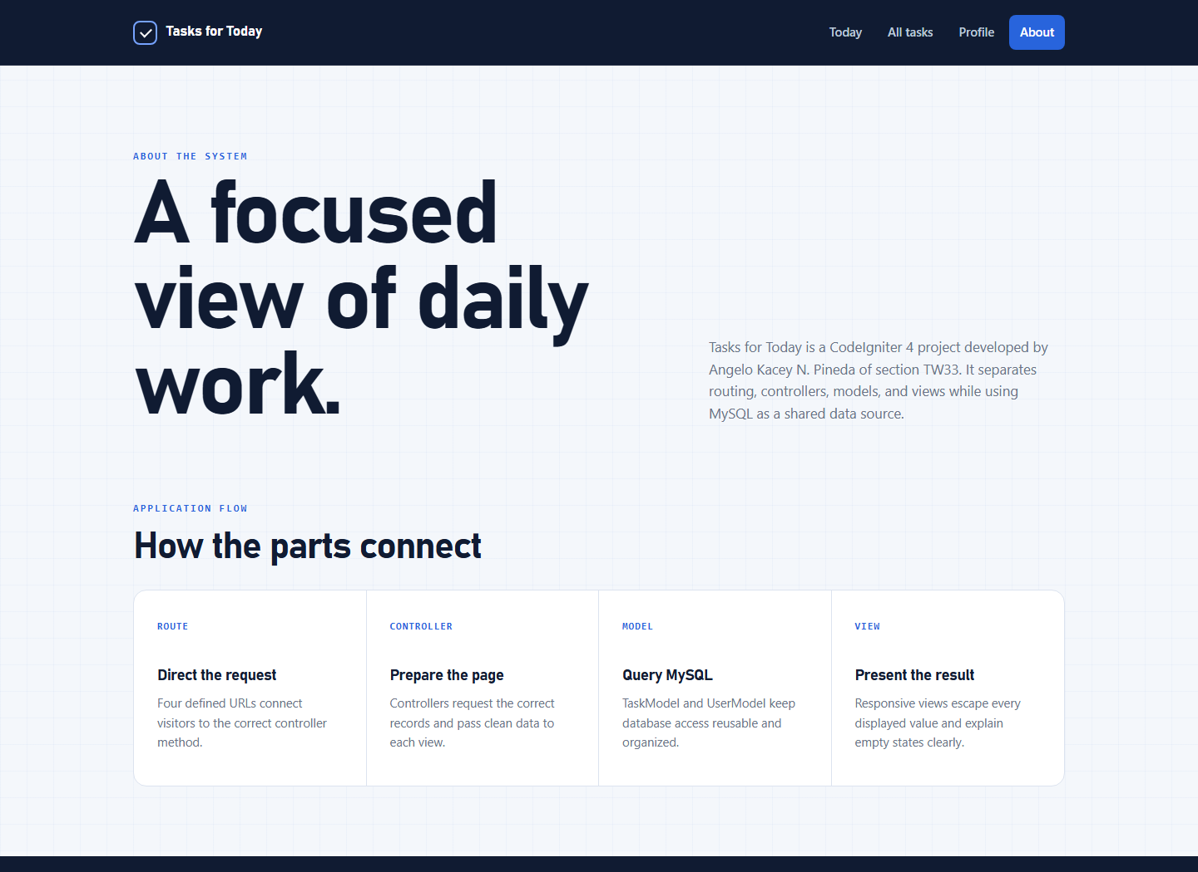
Figure 4. About page and MVC application flow.
- The developer name and section are visible on the page.
- The four MVC responsibilities are explained in plain language.
- The shared header and footer keep navigation consistent across all routes.

VERIFICATION

Testing and responsive review
Check | Result
PHP syntax | Passed for every PHP file in app
Defined routes | Four required GET routes registered
Automated tests | 7 tests passed with 14 assertions
Database counts | 8 tasks, 4 dates, 4 today tasks, 1 user
Desktop visual review | All four pages inspected with no overlap or clipping
Responsive visual review | Navigation, hero, statistics, and task cards adapt at 500 px

Submission status
The GitHub-ready source, database export, migrations, seeder, screenshots, README, hosting guide, and this report are included. A live hosted URL must still be added after deploying the application to a PHP and MySQL hosting provider.

References
- CodeIgniter 4 User Guide. Database Query Builder and where clauses. https://codeigniter4.github.io/userguide/database/query_builder.html
- CodeIgniter 4 User Guide. Database migrations and seeding. https://codeigniter4.github.io/userguide/dbmgmt/
- Manfield, A. (2021). Pro CodeIgniter: Learn how to create professional web-applications with PHP.

Responsive dashboard
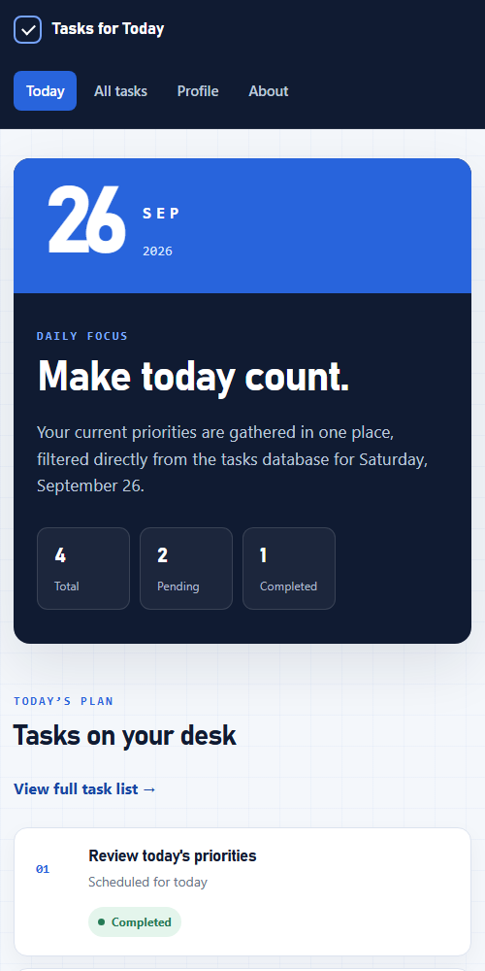 | Responsive behavior  - The navigation wraps into a second row without hiding any route.  - The date block and dashboard content stack vertically.  - Task status badges move below task titles when horizontal space is limited.  - Keyboard focus is visible and reduced-motion preferences are respected.

